

**ELEVATE LABS  
Cyber Security Internship**

**Task 7  
Documentation Report  
Submitted by Suhaila P.S**

**Task 7: Identify and Remove Suspicious Browser Extensions**

**Objective:** Learn to spot and remove potentially harmful browser extensions.

**Tools Used:**

* Google Chrome (Extensions Manager)

**Steps Taken & Findings:**

**1. Opened Browser’s Extension Manager**

* Accessed Chrome’s extensions page via: chrome://extensions/
* Reviewed all installed extensions.  
    
  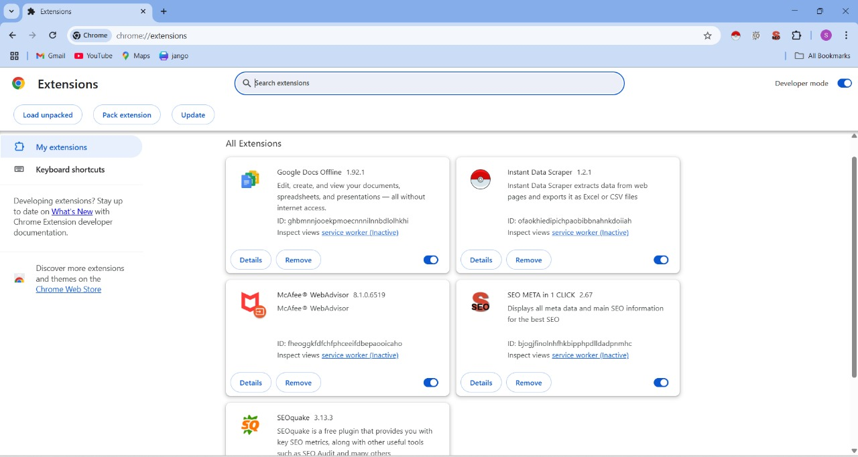  
  Figure 1 : All Extensions in chrome

**2. Reviewed Installed Extensions**

* Found the following extensions:

| **Extension Name** | **Source/Permissions** | **Risk Assessment** |
| --- | --- | --- |
| **McAfee® WebAdvisor** | Third-party install (bundled software) | ⚠️ Suspicious (unnecessary, broad permissions) |
| **Google Docs Offline** | Official Google extension | ✅ Safe (limited permissions) |
| **SEOquake** | SEMrush (SEO tool) | ⚠️ High permissions (reads browsing history) |
| **Instant Data Scraper** | Data scraping tool | ❗ High-risk (reads/changes all site data) |
| **SEO META in 1 CLICK** | SEO tool | ⚠️ Broad permissions (potential privacy risk) |

**3. Checked Permissions & Reviews**

* **McAfee WebAdvisor:**
  + Permissions: Reads/changes data on all sites, allowed in Incognito.
  + Risk: Added without explicit user consent (common in bundled software).
* **SEOquake & SEO META in 1 CLICK:**
  + Required access to browsing history and site data.
  + Useful for SEO professionals but risky if unused.
* **Instant Data Scraper:**
  + Could modify website data and access local files.
  + Some user reviews reported privacy concerns.

**4. Identified Suspicious/Unused Extensions**

* **To Remove:**
  + McAfee WebAdvisor (not actively used, third-party installed)
  + Instant Data Scraper (high-risk permissions)
  + SEOquake & SEO META in 1 CLICK (unused, excessive permissions)
* **To Keep:**
  + Google Docs Offline (official, safe, useful)

**5. Removed Suspicious Extensions**

* **Steps for Removal:**
  1. Went to chrome://extensions/.
  2. Clicked **"Remove"** on each unwanted extension.
  3. Confirmed removal in the pop-up.
* **Extensions Removed:**
  1. McAfee WebAdvisor
  2. Instant Data Scraper
  3. SEOquake
  4. SEO META in 1 CLICK  
       
     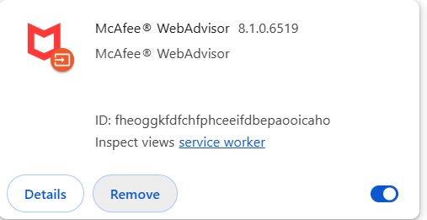  
       
     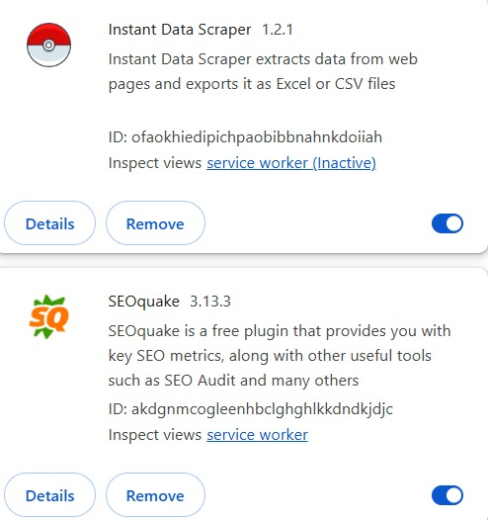  
     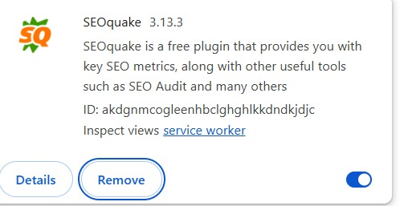

Figure 2,3,4 : Removed Extensions

**6. Restarted Browser & Checked Performance**

* **Observations After Removal:**
  + Faster browser performance.
  + No unexpected ads or redirects.
  + Cleaner extensions list (only Google Docs Offline remains).  
      
    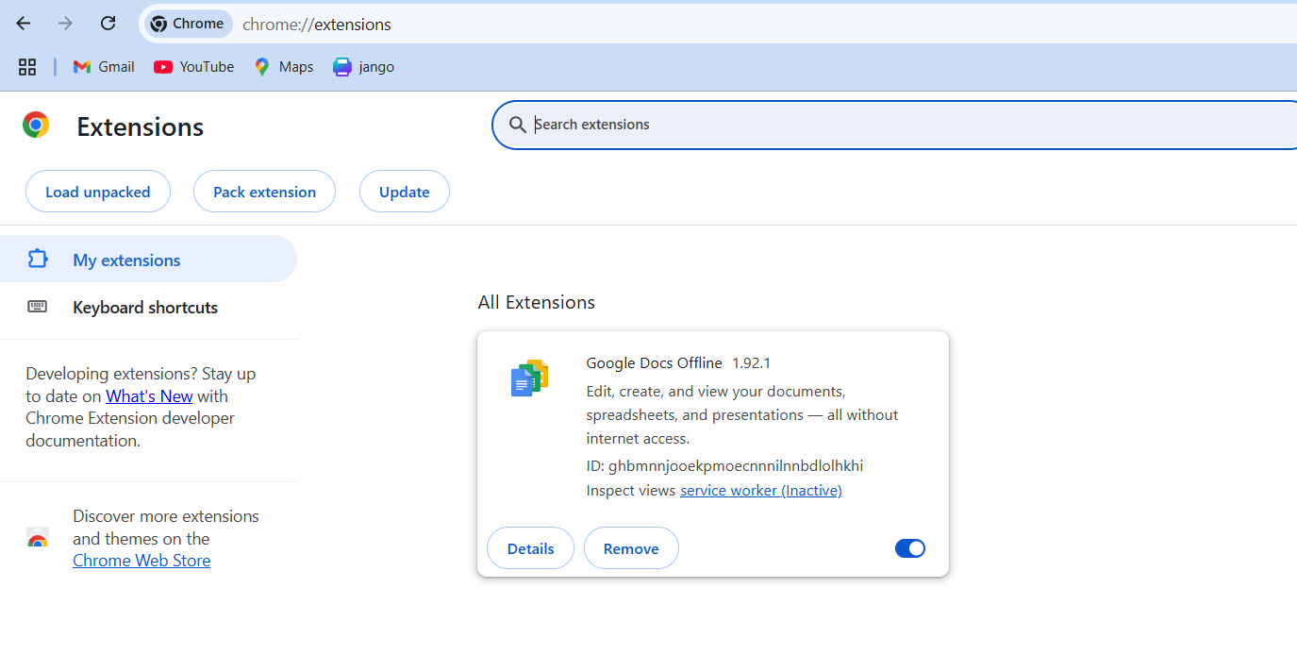  
    Figure 5 : Remaining Extension

**7. Research on Malicious Extensions**

**How Malicious Extensions Harm Users:**

* **Data Theft:** Steals passwords, credit card details, and browsing history.
* **Spyware Activity:** Tracks user behavior and sells data to third parties.
* **Malware Injection:** Installs viruses, ransomware, or keyloggers.
* **Ad Injection:** Floods users with malicious ads or phishing scams.
* **Incognito Tracking:** Some bypass private browsing protections.
* **Fake Functionality:** Masquerades as useful tools (e.g., "Download Managers") but performs harmful actions.

**Final Deliverables:**

✅ **List of Suspicious Extensions Found & Removed:**

1. **McAfee WebAdvisor** (Third-party bundled, unnecessary)
2. **Instant Data Scraper** (High-risk data access)
3. **SEOquake** (Unused, broad permissions)
4. **SEO META in 1 CLICK** (Unused, excessive access)

✅ **Extensions Kept:**

* Google Docs Offline (safe, official)

✅ **Performance After Removal:**

* Faster browsing, no unexpected behavior.

**Key Takeaways:**

**Browser Security Best Practices:**

* Regularly audit installed extensions.
* Remove unused or suspicious add-ons.
* Check permissions before installing new extensions.
* Prefer extensions from official stores (Chrome Web Store, Firefox Add-ons).
* Avoid third-party bundled software that installs extensions silently.

**Outcome:** Increased awareness of browser security risks and proper extension management.